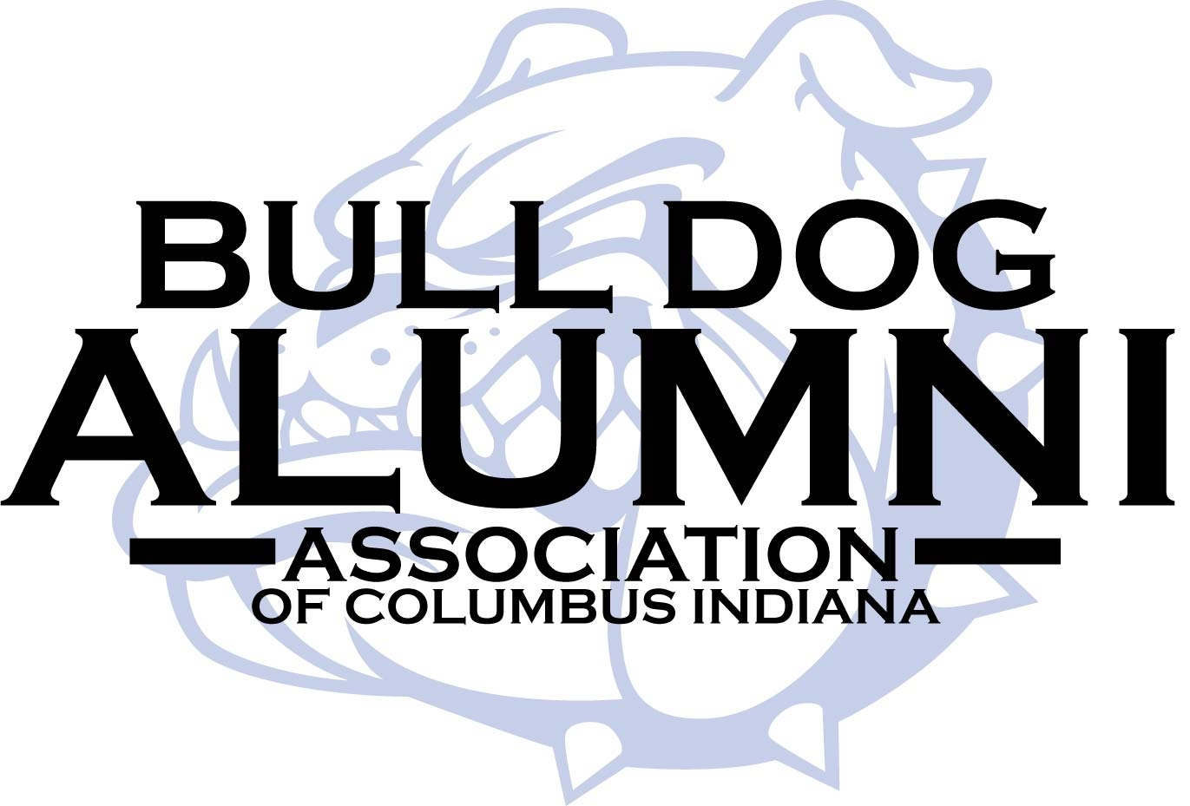

The mission of the Bull Dog Alumni Association is to support and promote Columbus North High School in its pursuits of excellence in teaching, student life activities and public service and to foster a spirit of loyalty, involvement and lifelong commitment to Columbus North High School.

Bull Dog Alumni grants are awarded to teachers and staff for professional and curriculum development, equipment/supplies and fees for student activities, which will help provide positive learning experiences for students.

Grant Application
for Columbus North High School Faculty & Staff
2025-26

Please submit this application electronically to cnhsalumni@bcsc.k12.in.us. Align your project with the BCSC District Initiatives and Universal Design for Learning. If any questions, please contact Hedy George, Executive Director, www.cnhsalumni@bcsc.k12.in.us.

Name

Teaching Assignment/Department

Contact Phone No Email

Project Title

Amount Requested* Total Cost of Project*

Date when funds are needed

Project Summary---Include how your project will use the principles and guidelines of UDL

Goals of Project

Number of students served

Other funding sources available/utilized

*Please submit an itemized list of expenditures for this project.

If you receive this grant, you may be asked to provide a brief summary of the completed project and an accounting of the funds to the Bull Dog Alumni Board of Directors at one of its quarterly meetings. Date to be determined--

